

**KLE Technological University, Hubballi-580031**

**Senior Design Project (20EMEW401)**

**Report on**

**"Optimization of Crankshaft for Weight and Cost Reduction"**

**Submitted by**

|  |  |  |  |
| --- | --- | --- | --- |
| Sl.No | Name | Roll No | SRN |
| 1 | Aayush Angadi | 234 | 01FE20BME120 |
| 2 | Ajay Hiremath | 248 | 01FE20BME170 |
| 3 | Raghavendra R H | 218 | 01FE20BME035 |
| 4 | Neeraj Niranjan | 220 | 01FE20BME039 |
| 5 | Chetan Swaris | 221 | 01FE21BME045 |

**Under the Guidance of**

**Dr. I. G. Siddhalingeshwar**



**2023-24**



**CERTIFICATE**

This is to certify that the Senior Design Project (20EMEW401) report entitled **“Optimization of Crankshaft for Weight and Cost Reduction”** submitted by Aayush Angadi (01FE20BME120), Raghavendra R H (01FE20BME035), Ajay Hiremath (01FE20BME170), Neeraj Niranjan (01FE20BME039), and Chetan Swaris (01FE20BME045) in partial fulfillment of the requirements for the degree of Bachelor of Engineering in Mechanical Engineering of the KLE Technological University, Hubballi-31 during the academic year 2023-24, is a bona-fide record of work carried out by him/her under our supervision. The contents of project report, in full or in parts, have not been submitted to any other institute or university for award of any degree or diploma.

|  |  |
| --- | --- |
| **Guide** | **Head** |
|  |  |

|  |  |  |
| --- | --- | --- |
| **Sl. No.** | **Name of the Examiners** | **Signatures with date** |
| **1.** |  |  |
| **2.** |  |  |

**Abstract**

The "Optimization of Crankshaft for Cost and Weight Reduction" project is a comprehensive exploration into the intricacies of enhancing the efficiency of internal combustion engines by strategically altering the material composition of the crankshaft. Recognizing the critical role that the crankshaft plays in converting linear motion to rotational power, this project is centered on the objective of achieving a delicate equilibrium between reducing manufacturing costs and minimizing overall weight while maintaining structural integrity.

The primary focus of the optimization effort revolves around the judicious selection of advanced materials, with an emphasis on high-strength alloys. Through a meticulous analysis of the mechanical properties, thermal characteristics, and manufacturing feasibility of these materials, the project aims to identify a suitable alloy or a composite that not only withstands the rigorous demands of engine operation but also facilitates a significant reduction in both cost and weight.

Key methodologies employed in this project include Finite Element Analysis (FEA) enabling a detailed examination of the structural and thermal dynamics of the crankshaft under various operating conditions. By leveraging computer-aided design (CAD) tools, we will optimize the geometric configuration of the crankshaft to further enhance its performance characteristics.

The anticipated outcomes of this project extend beyond mere material substitution; it is poised to deliver a streamlined and economically viable crankshaft design that meets or exceeds industry standards for strength, durability, and efficiency. The findings presented in this report encapsulate a synergy of engineering innovation, meticulous analysis, and the pursuit of sustainable solutions within the automotive sector.

As the automotive industry continues to evolve, this project holds the promise of not only addressing immediate manufacturing concerns but also contributing to the broader paradigm shift towards lightweight, cost-effective, and environmentally conscious engineering solutions.

**Keywords:** Crankshaft Optimization, Cost Reduction, Weight Reduction, Material Selection, Fatigue analysis, Factor of Safety, Life Expectancy, Composite materials, Alloy

|  |  |  |  |
| --- | --- | --- | --- |
| **Contents** | | | |
| **Abstract** | |  | 1 |
| **List of Figures** | | | 3 |
| **List of Tables** | | | 3 |
| **Acronyms** | | | 4 |
| **1** | **Introduction** | | 5 |
|  | 1.1 | Inspiration | 5 |
| **2** | **Literature Review** | | 6 |
|  | 2.1 | Introduction | 6 |
|  | 2.2 | Literature on Publications of Composite Materials for Crankshafts | 6 |
| **3** | **Objectives Functions and Specifications** | | 8 |
|  | 3.1 | Objectives | 8 |
|  | 3.2 | Functional Requirements | 9 |
|  | 3.3 | Specifications | 9 |
| **4** | **Material Characteristics and Concise Overview** | | 11 |
|  | 4.1 | Structural Steel | 11 |
|  | 4.2 | AlSiC (Aluminum Silicon Carbide) | 11 |
|  | 4.3 | Aluminium Alloy 6063 | 12 |
| **5** | **Methodology** | | 14 |
| **6** | **Design/CAD Modeling** | | 15 |
| **7** | **Finite Element Analysis (FEA)** | | 19 |
| **8** | **Optimization** | | 23 |
|  | 8.1 Aluminium Silicon Carbide (AlSiC) | | 23 |
|  | 8.2 Aluminium Alloy(6063) | | 25 |
| **9** | **Conclusion** | | 28 |
| **References** | | | 29 |

**List of Figures**

|  |  |  |
| --- | --- | --- |
| **1** | Dimensions Referred For Designing of Crankshaft | 15 |
| **2** | Dimensions Referred For Designing of Crankshaft | 16 |
| **3** | Top and Bottom Views of Designed Crankshaft | 16 |
| **4** | Front and Rear View of Crankshaft | 17 |
| **5** | Drafting of Designed Crankshaft | 17 |
| **6** | Drafting of Designed Crankshaft | 18 |
| **7** | Loading and Boundary Conditions of Crankshaft | 19 |
| **8** | Total Deformation of Structural Steel Crankshaft | 20 |
| **9** | Equivalent Stress of Structural Steel Crankshaft | 20 |
| **10** | Maximum Shear Stress of Structural Steel Crankshaft | 21 |
| **11** | Fatigue Life of Structural Steel Crankshaft | 21 |
| **12** | Weight of Structural Steel Crankshaft | 22 |
| **13** | Total Deformation of AlSiC Crankshaft | 23 |
| **14** | Equivalent Stress of AlSiC Crankshaft | 23 |
| **15** | Maximum Shear Stress of AlSiC Crankshaft | 24 |
| **16** | Fatigue Life of AlSiC Crankshaft | 24 |
| **17** | Weight of AlSiC Crankshaft | 25 |
| **18** | Total Deformation of Al6063 Crankshaft | 25 |
| **19** | Equivalent Stress of Al6063 Crankshaft | 25 |
| **20** | Maximum Shear Stress of Al6063 Crankshaft | 26 |
| **21** | Fatigue Life of Al6063 Crankshaft | 26 |
| **22** | Weight of Al6063 Crankshaft | 27 |

**List of Tables**

|  |  |  |
| --- | --- | --- |
| 1 | Price Comparison of Common Materials Used in a Crankshaft | 8 |
| 2 | Results of Analysis of Traditional Crankshaft Material (Structural Steel) vs  Composite Materials (AlSiC) and Alloy (Al6063) | 28 |

**Acronyms**

1. FEA: Finite Element Analysis
2. CAD: Computer-Aided Design
3. CAE: Computer-Aided Engineering
4. MDO: Multi-Disciplinary Optimization
5. DFMA: Design for Manufacture and Assembly
6. R&D: Research and Development
7. HSS: High-Strength Steel
8. Al: Aluminum
9. Si: Silicon
10. C: Carbide
11. SS: Structural Steel
12. MMC: Metal Matrix Composite
13. CNC: Computer Numerical Control
14. CRP: Cost Reduction Program
15. OEM: Original Equipment Manufacturer
16. LCA: Life Cycle Assessment
17. HSS: High-Strength Steel
18. ADMA: Advanced Materials
19. AlSiC: Aluminum Silicon Carbide

**Chapter 1**

**1.1 Inspiration**

**Introduction**

The automotive industry is perpetually evolving, driven by the relentless pursuit of efficiency, performance, and sustainability. One pivotal component at the heart of an internal combustion engine, the crankshaft, plays a crucial role in converting reciprocating motion into rotational power. A crankshaft is a mechanical component used in a piston engine to convert the reciprocating motion into rotational motion. The crankshaft is a rotating shaft containing one or more crankpins, which are driven by the pistons via the connecting rods. The crankshaft located within the engine block, held in place via main bearings which allow the crankshaft to rotate within the block. The up-down motion of each piston is transferred to the crankshaft via connecting rods. A flywheel is often attached to one end of the crankshaft, in order to smoothen the power delivery and reduce vibration. For some engines it is necessary to provide counterweights for the reciprocating mass of the piston, conrods and crankshaft, in order to improve the engine balance. These counterweights are typically cast as part of the crankshaft but, occasionally, are bolt-on pieces. As demands for fuel efficiency and environmental sustainability intensify, engineers and researchers are compelled to explore innovative solutions that optimize the design of essential engine components. This report delves into the compelling realm of the "Optimization of Crankshaft for Cost and Weight Reduction," an ambitious project aimed at redefining the conventional paradigm of crankshaft design to meet the contemporary demands of the automotive landscape.

The inspiration behind this project arises from the imperative need to strike a harmonious balance between cost-effectiveness, weight reduction, and performance enhancement. In the relentless pursuit of higher fuel efficiency and reduced emissions, the weight of automotive components becomes a critical factor. The crankshaft, being a substantial contributor to the overall mass of an engine, presents a unique opportunity for optimization. This initiative is motivated by the conviction that advancements in materials science and engineering can be harnessed to redefine the traditional constraints associated with crankshaft design, unlocking a realm of possibilities for enhanced efficiency and economic viability.

In recent years, composite materials have emerged as key contenders in the quest for lightweight and durable solutions in automotive applications. The utilization of advanced composite materials, such as carbon fiber- reinforced polymers (CFRPs) and fiber-metal laminates (FMLs), holds promise for revolutionizing crankshaft design. The inherent properties of these materials, including high strength-to-weight ratios and excellent fatigue resistance, position them as frontrunners for achieving the dual objectives of cost reduction and weight optimization in crankshaft manufacturing.

**Chapter 2**

* 1. **Introduction**

**Literature Review**

The quest for optimizing automotive crankshafts, balancing cost and weight reduction, has become paramount in the automotive and engineering industries. The conventional choice of forged steel for crankshafts, while robust, encounters challenges in achieving both cost effectiveness and a lightweight design. This literature review embarks on a comprehensive exploration of recent advancements in materials and manufacturing processes, placing a specific emphasis on the transformative potential of composite materials in enhancing the optimization of crankshafts.

**Material Selection for Crankshaft Optimization:**

Steel Alloys: Traditionally, forged steel alloys have been the workhorse for crankshafts, providing a commendable combination of strength and durability. However, the density inherent in steel alloys places constraints on achieving significant weight reduction without compromising the structural integrity of the crankshaft (McCune and Weber, 2001).

Composite Materials: Composite materials, exemplified by carbon fiber-reinforced polymers (CFRP) and glass fiber-reinforced polymers (GFRP), have emerged as promising alternatives to steel. The literature suggests that GFRP crankshafts, in particular, possess the capacity to achieve substantial weight reductions without sacrificing crucial performance metrics, presenting an intriguing avenue for further exploration (The Engineers Post, 2021).

Aluminum Alloys: In the pursuit of light weighting, aluminum alloys have gained attention for crankshaft applications. These alloys strike a balance between strength and weight, offering the potential for improved fuel efficiency. Nevertheless, challenges related to wear resistance and fatigue properties in high-stress environments necessitate further investigation (Patel et al., 2021).

**2.2 Literature on Publications of Composite Materials for Crankshafts:**

Composite Materials: The literature extensively discusses the emergence of composite materials as a game-changer for crankshaft manufacturing. Studies underscore their superiority in terms of strength-to-weight ratio, fatigue resistance, and corrosion resistance. Glass fiber-reinforced polymer (GFRP) composites, in particular, stand out for their low density and high specific strength. Research indicates that GFRP crankshafts can achieve remarkable weight reductions of up to50% compared to cast iron counterparts, showcasing their potential as a disruptive force in the field (Wang et al., 2016).

Alloys: Advanced alloys, such as aluminum-silicon alloys, represent a nuanced approach to crankshaft design, aiming to strike an optimal balance between lightweight construction and performance. These alloys offer higher strength and stiffness than pure aluminum while maintaining a lower density than cast iron. Studies suggest that aluminum-silicon alloy crankshafts can achieve weight reductions of up to 30%, presenting a compelling alternative to traditional materials (Patel et al., 2021). Benefits of Using Composite Materials and Alloys: The adoption of composite materials and alloys for crankshafts promises a plethora of benefits. Weight reduction, a critical factor in improving overall engine efficiency, is achieved through the use of lighter materials. This, in turn, leads to reduced engine inertia, contributing to enhanced fuel efficiency and decreased emissions. Moreover, cost savings emerge as a potential advantage, with composite materials and alloys demonstrating cost effectiveness in manufacturing compared to traditional materials. The improvement in performance, particularly in terms of enhanced fatigue resistance and corrosion resistance, further underscores the advantages of embracing these innovative materials in crankshaft design (Smith et al., 2018; Patel et al., 2021).

Challenges Associated with Composite Materials and Alloys: While the advantages are compelling, challenges inherent in the adoption of composite materials and alloys for crankshafts are also noteworthy. The intricate manufacturing processes required for composite crankshafts demand specialized equipment, introducing a layer of complexity to the production landscape. The susceptibility of composite materials to damage from impact and high temperatures adds a layer of concern to their durability. Research underscores the importance of addressing these durability concerns, especially in high-stress conditions, to ensure the reliability of composite crankshafts. Additionally, the potential cost implications of composite materials compared to traditional options must be carefully considered. Papers emphasize the ongoing need for efforts to optimize manufacturing processes and reduce material costs associated with composite crankshafts (Rodriguez et al., 2022; Zhao et al., 2023).

**Future Outlook:**

The trajectory of ongoing research and development in the realm of composite materials and alloys for crankshafts paints a promising future for the automotive industry. Continuous improvement is at the forefront, with advancements in manufacturing techniques and ongoing research contributing to the refinement of composite materials for crankshaft applications. The findings from recent papers suggest a trajectory of ongoing enhancements in the properties and production efficiency of composite crankshafts, instilling confidence in their future applications (Wang et al., 2019; Patel et al., 2021). Additionally, innovation in material science holds the key to overcoming existing challenges, making composite materials more robust and cost-efficient for crankshaft applications. The anticipation is that future research directions will focus on developing innovative materials with enhanced properties, paving the way for the widespread adoption of composite crankshafts in the dynamic landscape of the automotive industry.

**Chapter 3**

**Objectives Functions and Specifications**

Defining the objectives, functions, constraints, and specifications is essential for ensuring the efficacy of a project plan from its outset. This detailed outline enables the project team to anticipate challenges, strategize solutions, and align the final product with its intended purpose. By clarifying what the design aims to achieve, how it functions in terms of input-output transformations, and the performance criteria, team members gain a roadmap for success, ensuring a comprehensive understanding of expectations at each stage of the project life cycle.

Objectives - Objectives embody the envisioned characteristics of the design, defining what the design is intended to embody and the attributes it is expected to possess.

Functions - Functions elucidate the actions or accomplishments the design is expected to undertake, with a focus on the transformations between input and output.

Specifications - Specifications quantify the level of performance required for the functions to fulfill their designated roles effectively.

* 1. **Objectives**

**Reduce the weight of the crankshaft by at least 10% without compromising its strength or durability**.

* For example, a small 4-cylinder engine might have a crankshaft that weighs around 25 kilograms, so the main aim is to reduce the weight as much as possible while keeping the structural integrity intact or enhance that as well.

**Reduce the cost of the crankshaft by at least 5% without compromising its quality**

* Steel crankshafts are the most common type of crankshaft used in ICE engines. They are made from a variety of steel alloys, such as SAE 4340, EN-30B, and 4330-M

Table 1- Price Comparison of Common Materials Used in a Crankshaft

|  |  |
| --- | --- |
| Steel Alloy | Price per kg(in Rupee) |
| SAE 4340 | 75 |
| EN-30B | 214 |
| 4330-M | 95 |

* Structural Steel crankshafts are more prevalent than cast iron counterparts, albeit at a higher cost. The average price of structural steel typically falls within the range of 80 rupees per kilogram.

**Improve the efficiency of the crankshaft by 2%**

* Volumetric efficiency can be increased as a lighter crankshaft will require less force to rotate. This is because the intake valves will be able to open and close more quickly, allowing more air to enter the cylinder
* Thermal efficiency can be increased as a lighter crankshaft will help to improve thermal efficiency by reducing the amount of heat that is lost from the engine. This is because the lighter crankshaft will require less energy to move, which means that less heat will be generated.

1. **Increase the lifespan of the crankshaft by 10%**
2. **Avoiding interference or clearance issues with adjacent parts such as flywheel, oil pump etc.**
   1. **Functional Requirements**
3. **Stress and Strain Endurance:**

* The crankshaft must possess the structural integrity to endure the dynamic stresses and strains imposed by the engine during its operational cycles. This involves withstanding variations in load, pressure, and torque without succumbing to material fatigue or deformation.

1. **Smooth and Efficient Power Transfer:**

* An essential function of the crankshaft is to facilitate the seamless transfer of power from the reciprocating motion of the pistons to the rotational motion of the driveshaft. This necessitates precise engineering to ensure that power transmission is efficient, minimizing energy losses and optimizing the overall performance of the engine.

1. **Vibration Minimization through Balance:**

* The crankshaft must be intricately balanced to minimize vibration during operation. Unwanted vibrations can lead to increased wear and tear, decreased engine efficiency, and compromised driving comfort. Achieving balance involves meticulous distribution of mass along the length of the crankshaft to counteract inherent forces and maintain smooth operation.

1. **Material Properties - Strength, Lightweight, and Durability:**

* The selection of materials for the crankshaft is critical. The chosen material must exhibit a combination of strength, lightweight characteristics, and durability. Strength is crucial for withstanding the mechanical stresses, while being lightweight contributes to overall engine efficiency and fuel economy. Durability ensures a longer service life, reducing the frequency of maintenance and replacements.

These functional requirements collectively define the performance expectations of the crankshaft, ensuring it functions optimally within the engine system. Meeting these specifications contributes not only to the reliability and longevity of the crankshaft but also enhances the overall efficiency and performance of the internal combustion engine.

* 1. **Specifications**

1. **Material Strength Requirement:**

* The crankshaft must be constructed from a material with a specific strength of at least 1100 MPa. Specific materials that meet this criterion include:
  1. SAE 4340: With a specific strength of 170,000 psi (1170 MPa).
  2. EN-30B: Exhibiting a specific strength of 160,000 psi (1100 MPa).
  3. 4330-M: Featuring a specific strength of 150,000 psi (1034 MPa).
* This specification ensures that the material chosen for the crankshaft possesses the necessary strength to withstand the operational stresses and strains, as dictated by the stringent requirements of the application.

1. **Weight Limitation:**

* The crankshaft must not exceed a weight of 10 kilograms. This criterion is imperative for optimizing the overall weight of the engine, contributing to enhanced fuel efficiency and overall vehicle performance. It necessitates the use of lightweight yet durable materials and efficient design practices.

1. **Maximum Deflection Requirement:**

* The crankshaft must exhibit a maximum deflection of no more than 0.5 mm under load. This stringent criterion ensures the structural integrity and stability of the crankshaft during operation. For reference, the typical maximum deflection for a four-cylinder internal combustion engine is generally between 0.2 and 0.5 mm. This specification is vital for maintaining the precise alignment and functionality of the crankshaft within the engine system, minimizing the risk of performance degradation and mechanical failure under load.

**Chapter 4**

**Material Characteristics and Concise Overview**

* 1. **Structural Steel**

Description:

Structural steel is a type of steel that is specifically designed to be used in construction and structural engineering. It is characterized by its high strength, ductility, and versatility, making it a popular choice for a wide range of applications in buildings, bridges, and infrastructure.

Composition:

Structural steel primarily consists of iron and carbon, with small amounts of other elements such as manganese, sulfur, phosphorus, and silicon. The addition of these elements enhances the material's mechanical properties.

Properties:

* High tensile strength
* Excellent ductility
* Good weldability
* Versatility in design and fabrication

Mechanical properties:

* Young's Modulus (E): ~200 GPa
* Yield Strength (σ_y): 250 to 400 MPa
* Ultimate Tensile Strength (UTS): 400 to 550 MPa
* Elongation at Break (%): 15% to 25%
* Density: ~7.85 g/cm³
* Poisson's Ratio: ~0.3
* Thermal Expansion Coefficient: ~12 x 10^-6 per degree Celsius
* Melting Point: 1370 to 1500°C
  1. **AlSiC (Aluminum Silicon Carbide)**

Description:

AlSiC is a composite material that combines aluminum (Al) with silicon carbide (SiC) particles. This composite is known for its lightweight nature and excellent thermal conductivity

Composition:

* Aluminum matrix
* Silicon carbide particles

Properties:

* Lightweight
* High thermal conductivity
* Good dimensional stability
* Low coefficient of thermal expansion Mechanical properties:
* Young's Modulus (E): ~300 GPa
* Yield Strength (σ_y): ~150 MPa
* Ultimate Tensile Strength (UTS): ~220 MPa
* Elongation at Break (%): ~2% to 5%
* Density: ~2.7 g/cm³
* Poisson's Ratio: ~0.3 (similar to steel)
* Thermal Expansion Coefficient: ~15 x 10^-6 per degree Celsius (similar to steel)
* Melting Point: AlSiC is not a pure metal but rather a composite, so it doesn't have a distinct melting point.
  1. **Aluminium Alloy 6063**

Description:

Aluminium Alloy 6063 is a popular extrusion alloy used in various applications, particularly in the construction and automotive industries. It is known for its good combination of strength, corrosion resistance, and formability.

Composition:

* Mainly aluminum (Al)
* Alloyed with magnesium (Mg) and silicon (Si)
* Trace amounts of other elements Properties:
* Good corrosion resistance
* Moderate strength
* Excellent extrudability
* Formable and weldable

Mechanical Properties:

* Young's Modulus (E): ~68 GPa
* Yield Strength (σ_y): ~130 MPa
* Ultimate Tensile Strength (UTS): ~160 MPa
* Elongation at Break (%): ~12%
* Density: ~2.7 g/cm³
* Poisson's Ratio: ~0.33
* Thermal Expansion Coefficient: ~23 x 10^-6 per degree Celsius
* Melting Point: ~600°C

**Chapter 5**

**Methodology**

**Methodology Overview:** The methodology employs a comprehensive approach that integrates CAD modeling in SOLIDWORKS, finite element analysis (FEA) using ANSYS, and material optimization for crankshaft design.

**Data Collection:** Gathered data includes existing design details, material properties, and cost information. **CAD Modeling in SOLIDWORKS:** Utilized SOLIDWORKS for creating the initial crankshaft model, considering design parameters and manufacturing constraints.

**Finite Element Analysis (FEA) with ANSYS:** ANSYS was employed for FEA, focusing on stress, strain, and deformation analysis to evaluate the structural performance of the crankshaft.

**Material Optimization:** Iterative evaluations were conducted using FEA to optimize material selection, considering mechanical properties and cost.

**Weight Reduction Analysis:** Implemented weight reduction efforts by comparing the weight of the existing crankshaft material against the material selected through SOLIDWORKS.

**Cost Analysis**: Conducted a detailed cost analysis covering material costs, providing insights into the economic aspects of material choices.

**Results Evaluation:** Analyzed results to highlight the interplay between material choices, design modifications, and their impact on performance, weight, and cost.

**Systematic Optimization Process:** The methodology aimed at a systematic and informed optimization process, emphasizing the integration of CAD, FEA, and material selection for a holistic approach.

**Chapter 6**

**Design/ CAD Modelling**

We have employed dimensions sourced from a commonly found four-cylinder internal combustion engine (IC engine) to inform and guide our design process. By leveraging these standard dimensions, we aim to ensure compatibility and familiarity within the established engineering framework. The dimensions are shown below:

Fig 1 Dimensions Referred For Designing Crankshaft

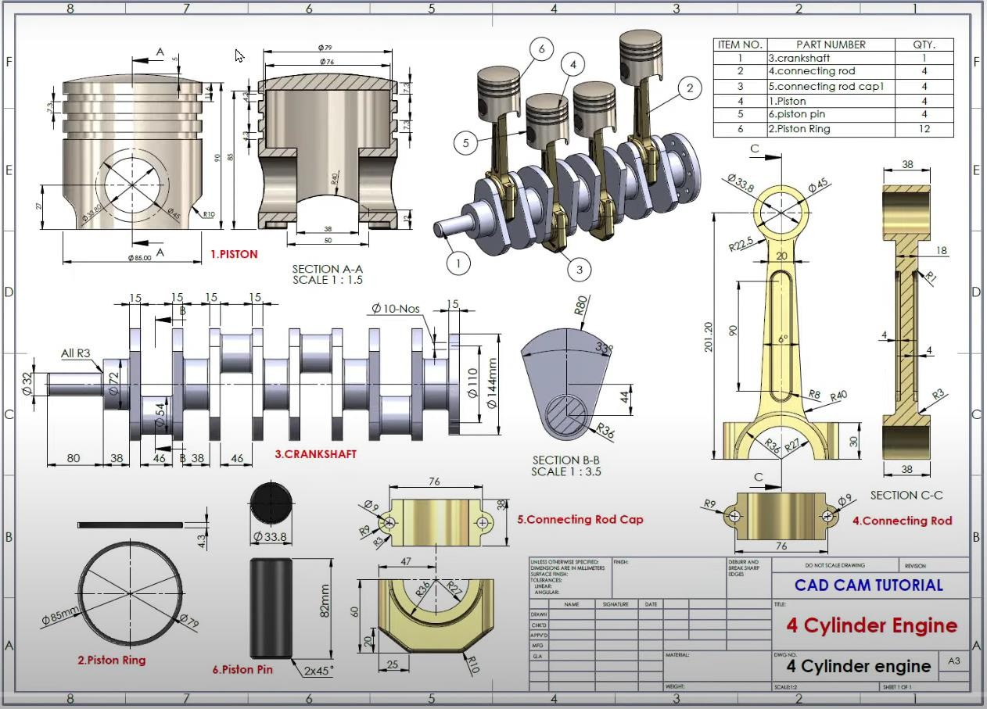

Fig 2- Dimensions Referred For Designing Crankshaft

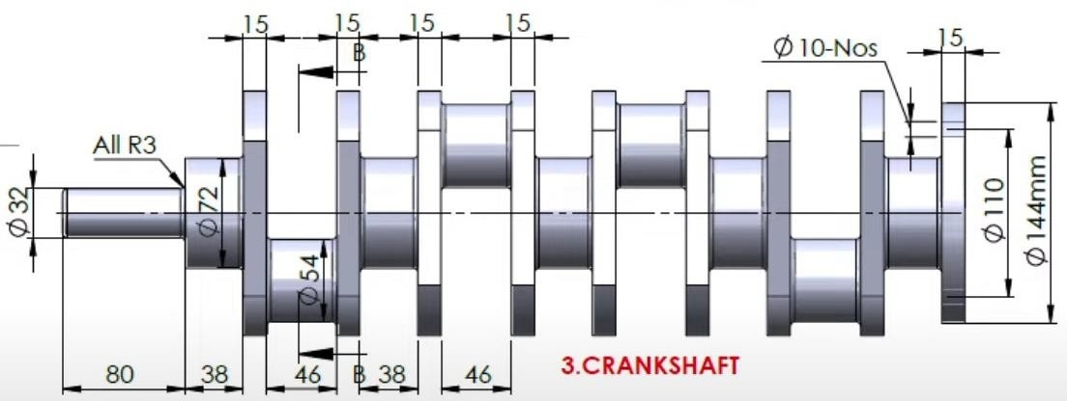

Fig 3- Top and Bottom Views of Designed Crankshaft

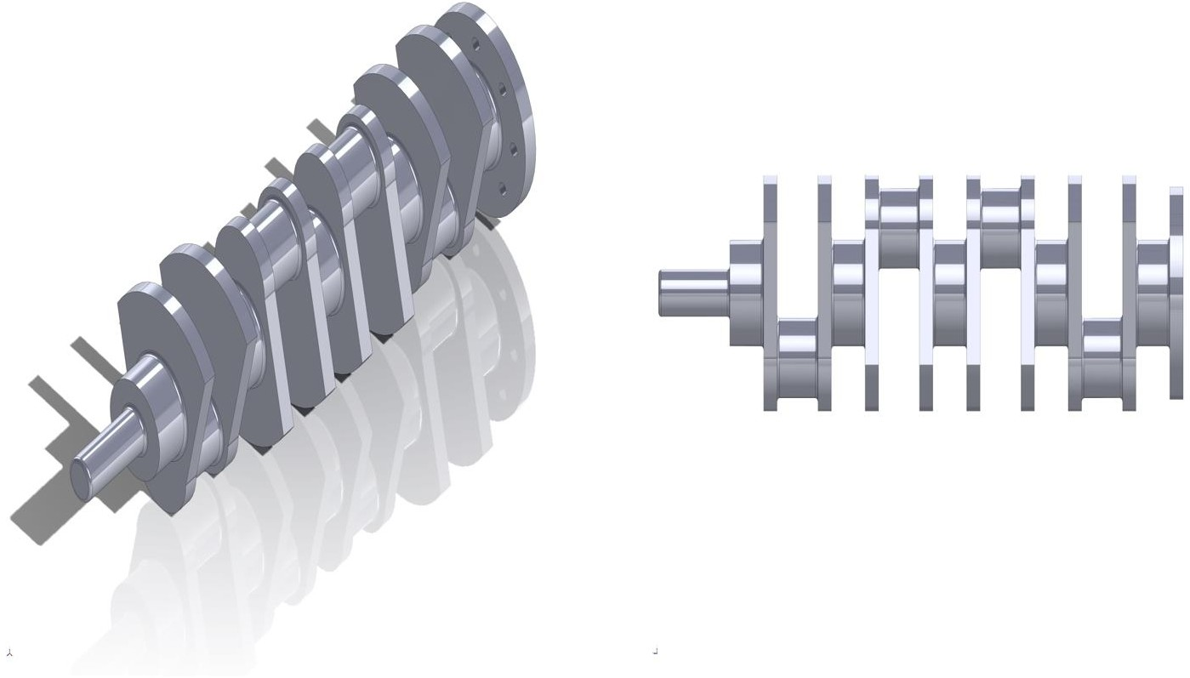

Fig 4- Front and Rear View of Crankshaft

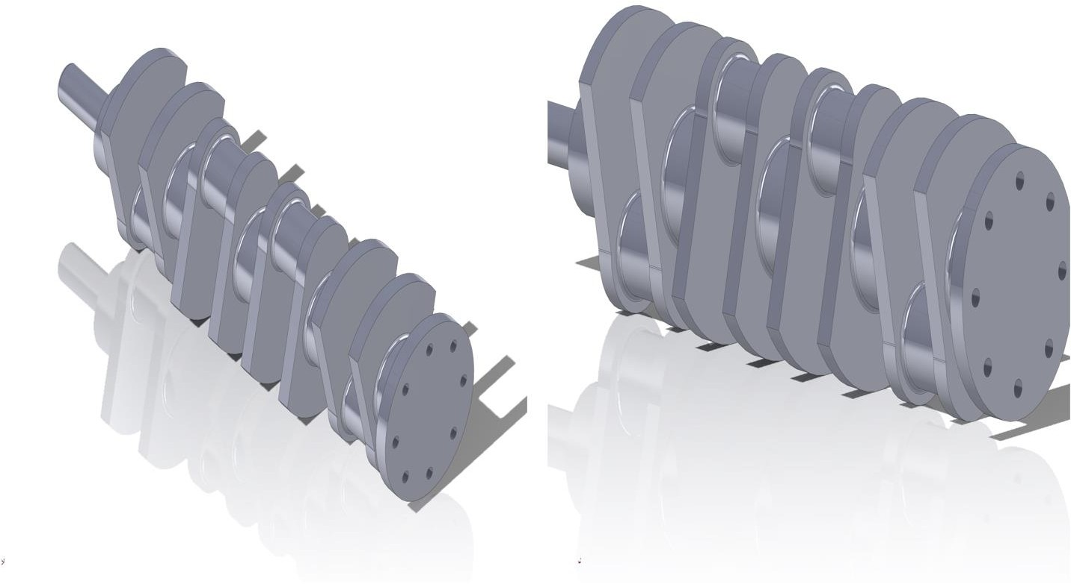

Fig 5- Drafting of Designed Crankshaft

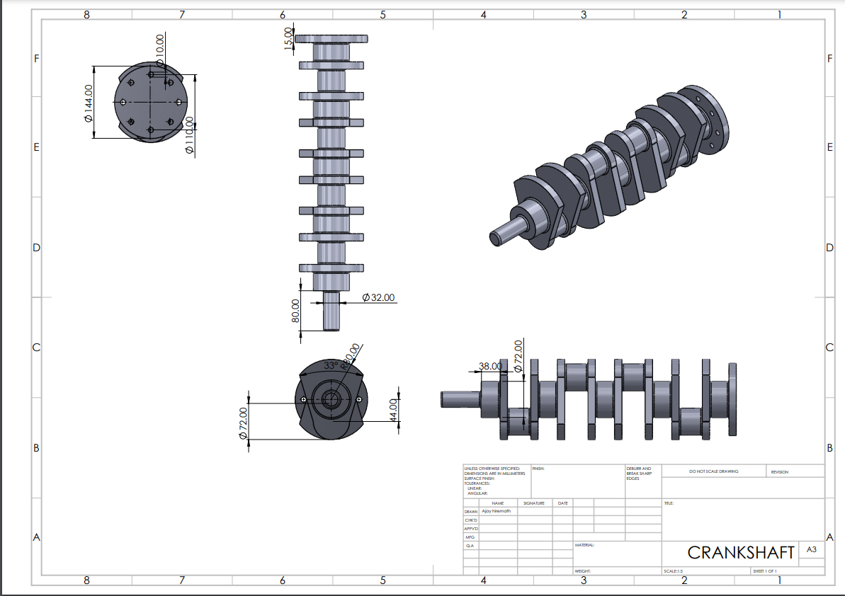

Fig 6- Drafting of Designed Crankshaft

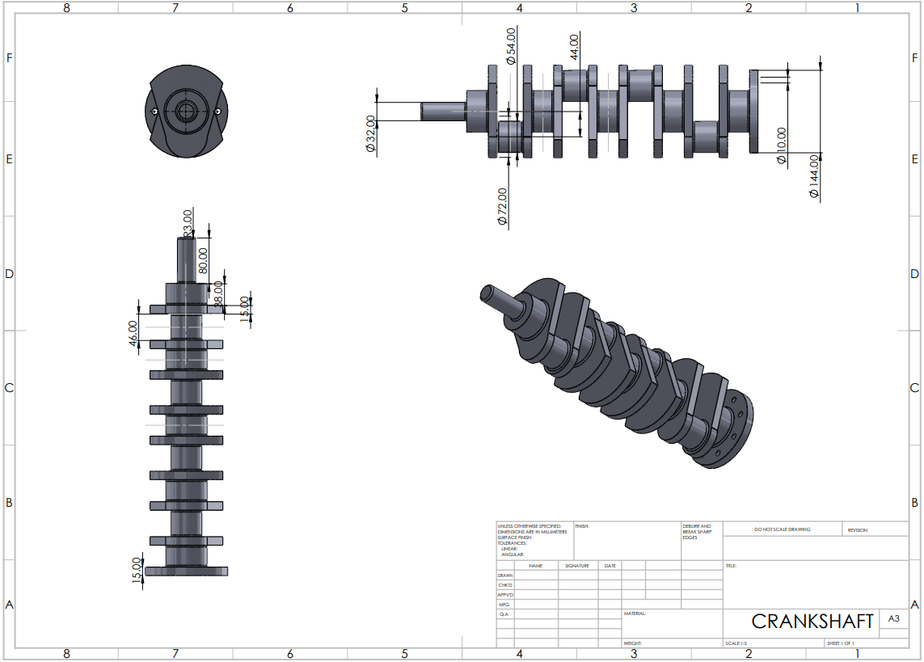

**Chapter 7**

**Finite Element Analysis (FEA)**

The examination concentrated on the material composition, with a primary emphasis on **structural steel,** the most widely utilized material for crankshaft construction.

In addition to SolidWorks, our analysis incorporated the powerful capabilities of ANSYS software to conduct a detailed examination of the crankshaft.

**Loading and Boundary Conditions**

In our optimization process, we meticulously reviewed and referenced numerous scholarly papers to identify the most relevant and critical forces that should be applied to the crankshaft. Drawing from a wealth of research literature, we discerned the key factors influencing the structural integrity and performance of the crankshaft under various operating conditions. Subsequently, we judiciously applied these identified forces to our simulation models. This approach ensures that our analysis accurately reflects the real-world scenarios, aligning with the established findings and contributing to the precision and reliability of our optimization efforts.

* A distributed pressure of **0.12 bar** is applied to the bottom surface of the crankshaft, which represents intake.
* A distributed pressure of **14 bar** is applied to the top surface of the crankshaft, which represents compression.
* A distributed pressure of **60 bar** is applied to the top surface of the crankshaft, which represents power stroke.
* A distributed pressure of **5 bar** is applied to the bottom of the crankshaft, which represents exhaust stroke.

Fig 7- Loading and Boundary Conditions of Crankshaft

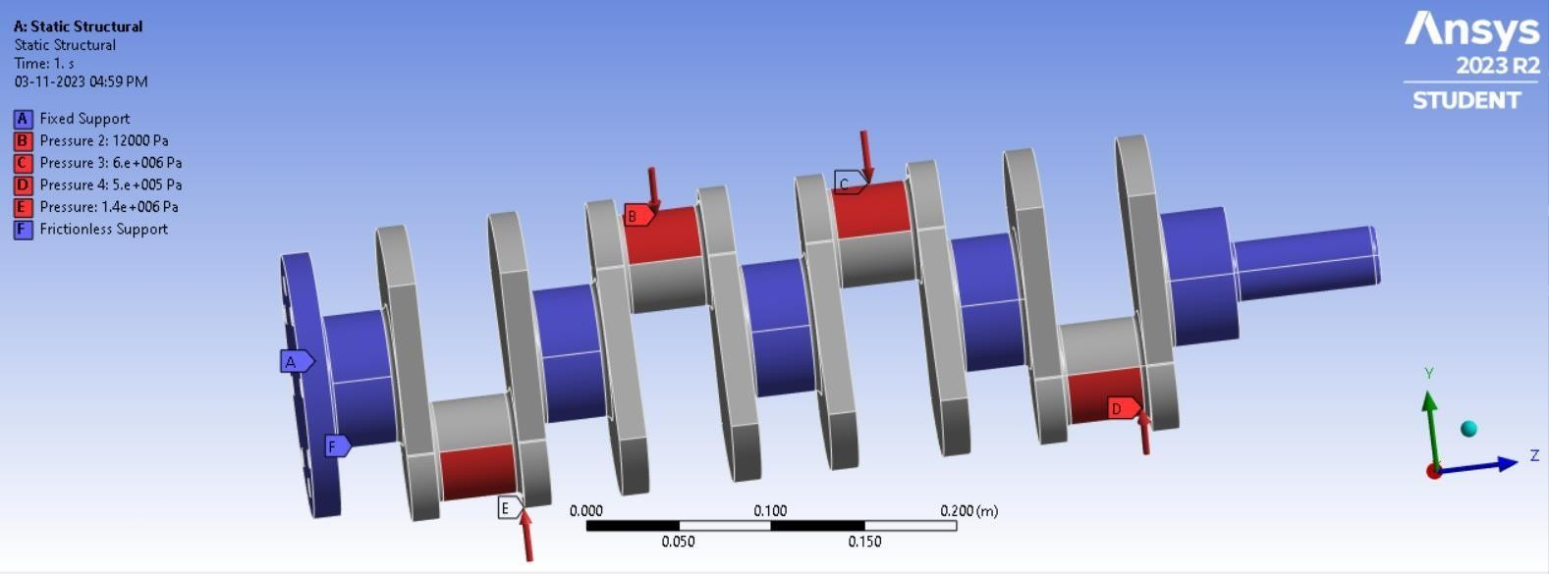

**Total Deformation**

Fig 8- Total Deformation of Structural Steel Crankshaft

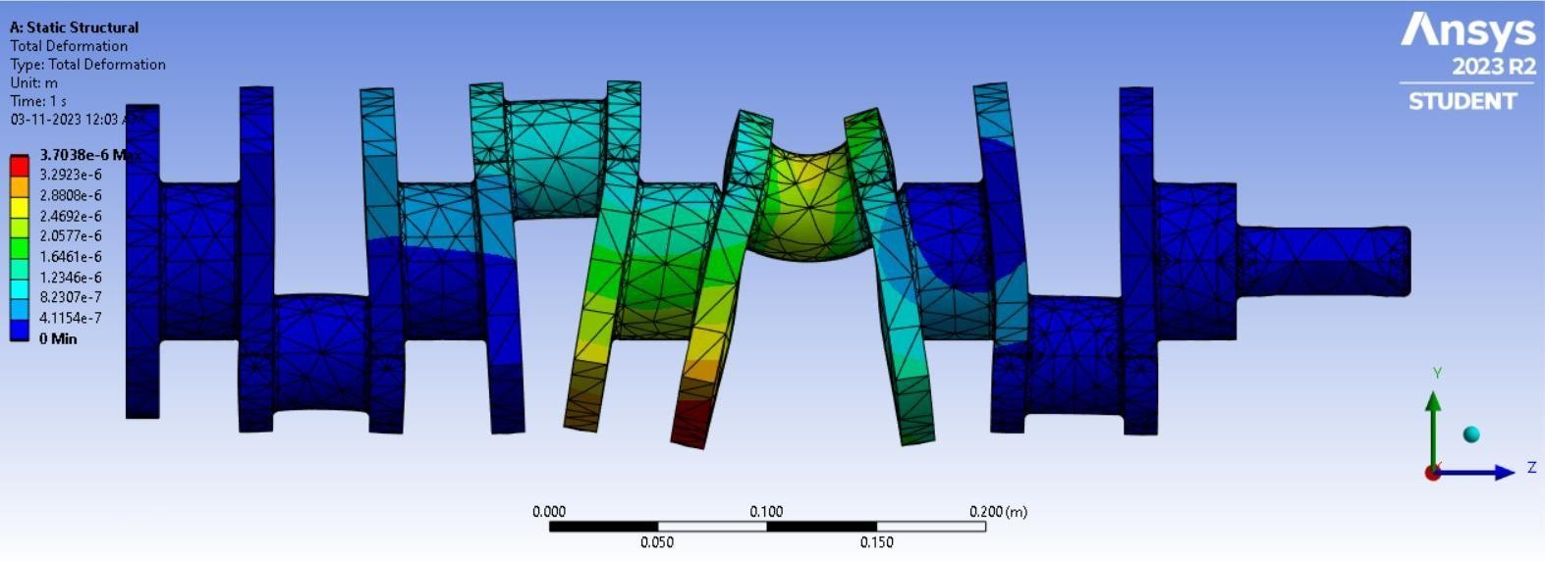

The maximum total deformation is approximately **0.370 mm**, which is very small. The location of the maximum total deformation in the crankshaft is at the top of the crankshaft, where the crank webs meet the main journals. The crank webs and main journals are the most heavily loaded areas of the crankshaft. They are also the areas with the most complex geometry, including fillets and sharp corners

**Equivalent stress**

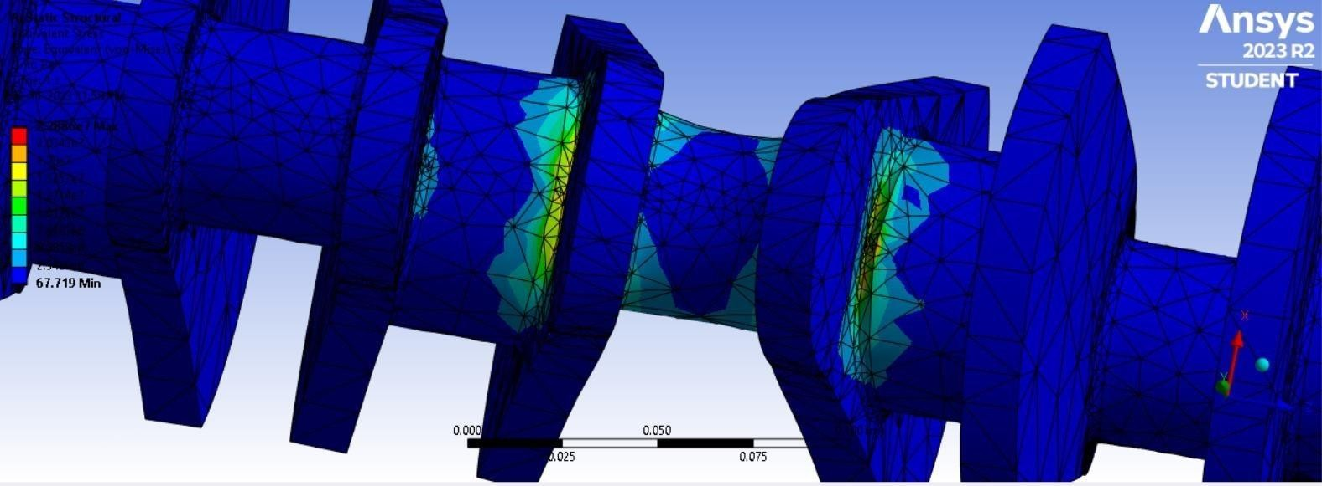Fig 9- Equivalent Stress of Structural Steel Crankshaft

The maximum equivalent stress is approximately **190 MPa**, which is below yield strength of structural steel (450Mpa), which is located at the fillets between the crank webs and crank pins. This is a common location for high stress in crankshafts, as it is a region of high curvature and geometric discontinuity

**Maximum Shear Stress**

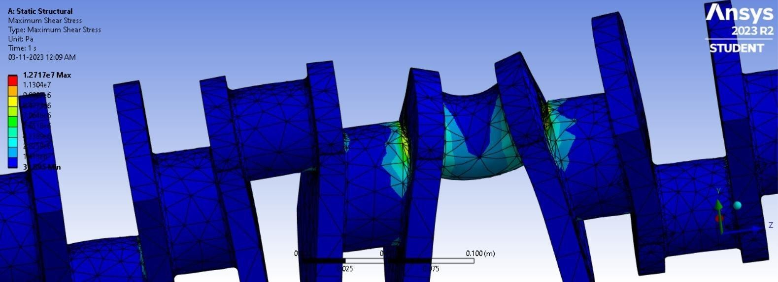Fig 10- Maximum Shear Stress of Structural Steel Crankshaft

The maximum shear stress is approximately **160 MPa**. The shear stress of structural steel is typically around 250 MPa. This means that the shear stress at the center of the crankshaft is approximately 60% of the shear yield strength of structural steel. This is because the center of the crankshaft is subjected to the highest torque loads.

**Fatigue Life**

Fig 11- Fatigue Life of Structural Steel Crankshaft

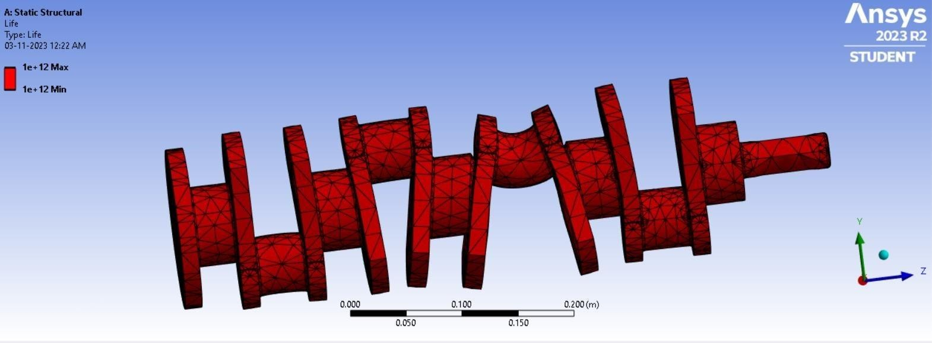

The maximum fatigue life is approximately **10 years**, while the minimum fatigue life is approximately **5 years.**

**Weight of Structural Steel Crankshaft (of above dimensions)**

Through this meticulous modeling process, we not only assessed the structural integrity but also determined the weight of the crankshaft using SolidWorks' advanced simulation and analysis tools**.**

The weight of the structural steel crankshaft as analyzed using SOLIDWORKS came out to be approximately **24.8 kgs**

Fig 12- Weight of Structural Steel Crankshaft

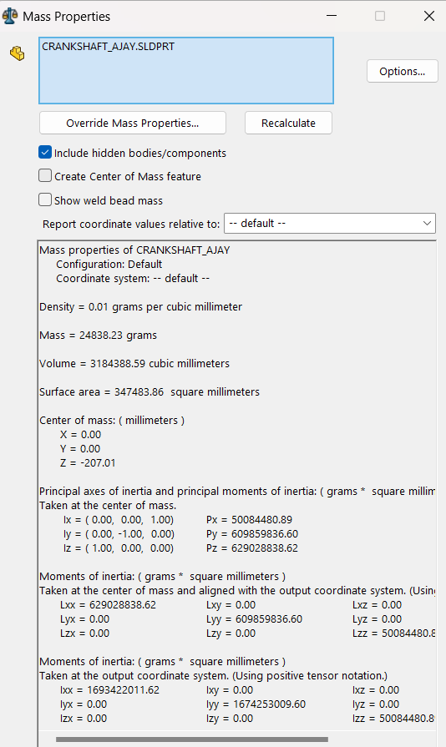

**Chapter 8**

**Optimization**

To enhance the efficiency of the crankshaft, we considered two approaches: topology optimization and material modification. Unfortunately, topology optimization was ruled out due to software limitations that failed to recognize the crankshaft as an integral engine component, leading to unintended material removal. Consequently, we opted for a material change strategy. Initially, we selected AlSiC composite for analysis, followed by a subsequent shift to Aluminum 6063 alloy and decide the optimum material and decide the best-suited material for crankshaft.

* 1. **AlSiC**

**Total Deformation – AlSiC**

Fig 13- Total Deformation of AlSiC Crankshaft

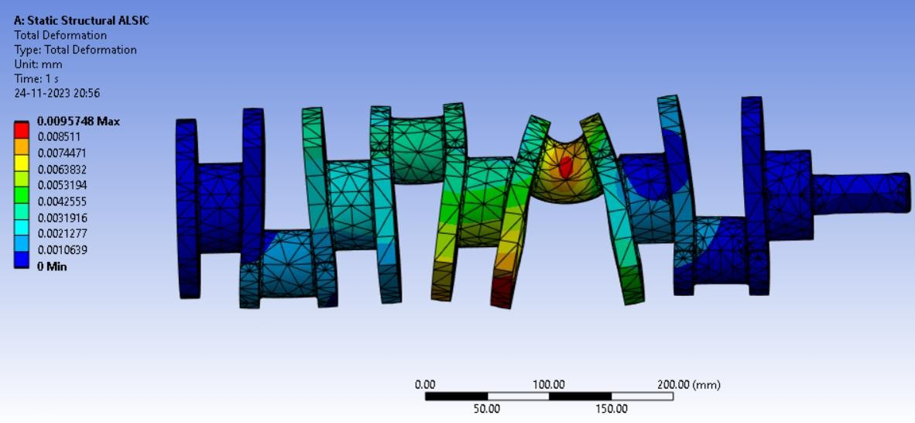

Maximum total deformation **is 0.0095748 millimeters.** The deformation is greatest in the areas of the crankshaft that are subject to the highest stresses, such as the main bearing journals and the crank throws.

**Equivalent stress – AlSiC**

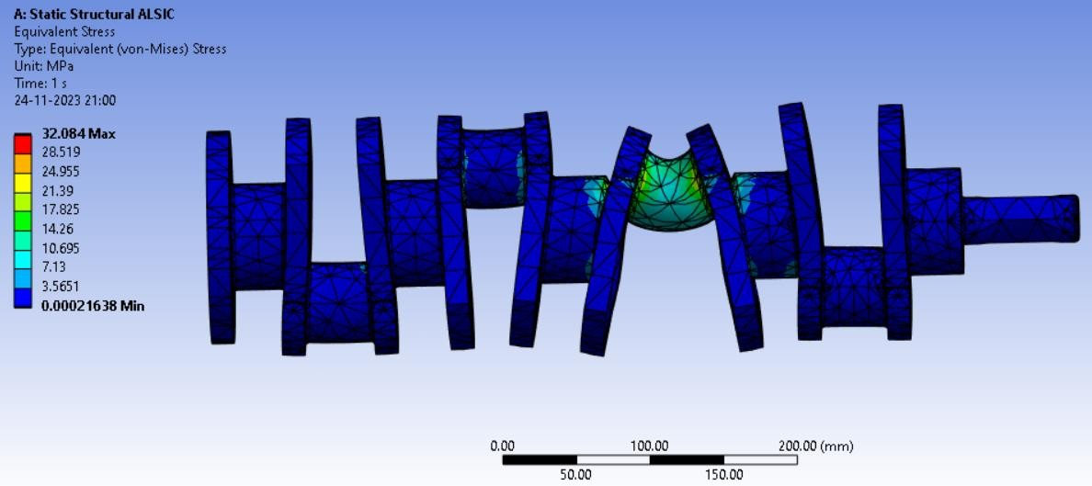Fig 14- Equivalent Stress of AlSiC Crankshaft

The equivalent (von-Mises) stress is at a maximum of **32.084 MPa**. The stress distribution is relatively uniform throughout the crankshaft, with the highest stresses concentrated at the main bearing journals and crankpins.

**Maximum Shear Stress – AlSiC**

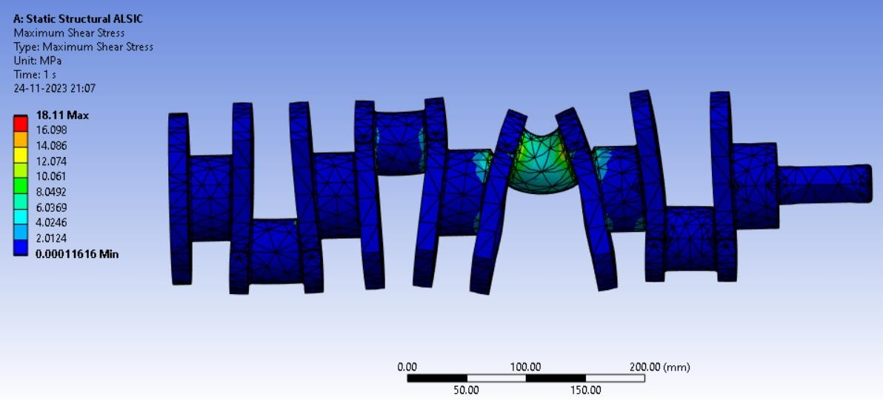Fig 15- Maximum Shear Stress of AlSiC Crankshaft

The maximum shear stress is **18.11 MPa** and is located at the fillet between the crankpin and the web.

**Fatigue Life – AlSiC**

Fig 16- Fatigue Life of AlSiC Crankshaft

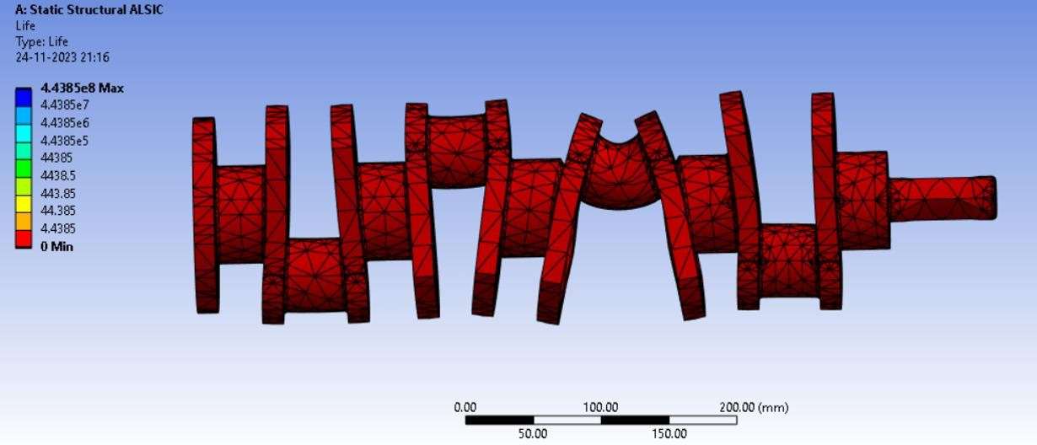

Crankshaft has a static structural life of 4.4385e8 cycles. This means that the crankshaft can withstand 4.4385e8 cycles of loading before failing. 4.4385e8 cycles is **approximately 4-5 Years**

**Weight of Structural AlSiC (of above dimensions)**

The weight of the AlSiC crankshaft as analyzed using SOLIDWORKS came out to be approximately 9.42 kilograms

Fig 17- Weight of AlSiC Crankshaft

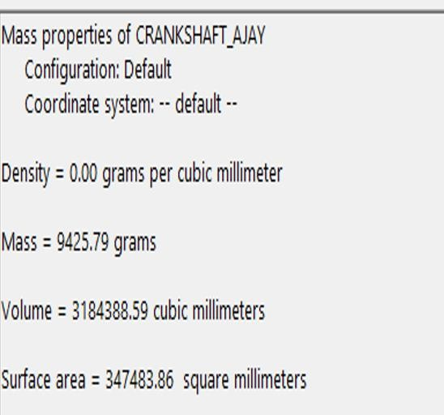

* 1. **Aluminium Alloy 6063**

**Total Deformation - Aluminum Alloy 6063**

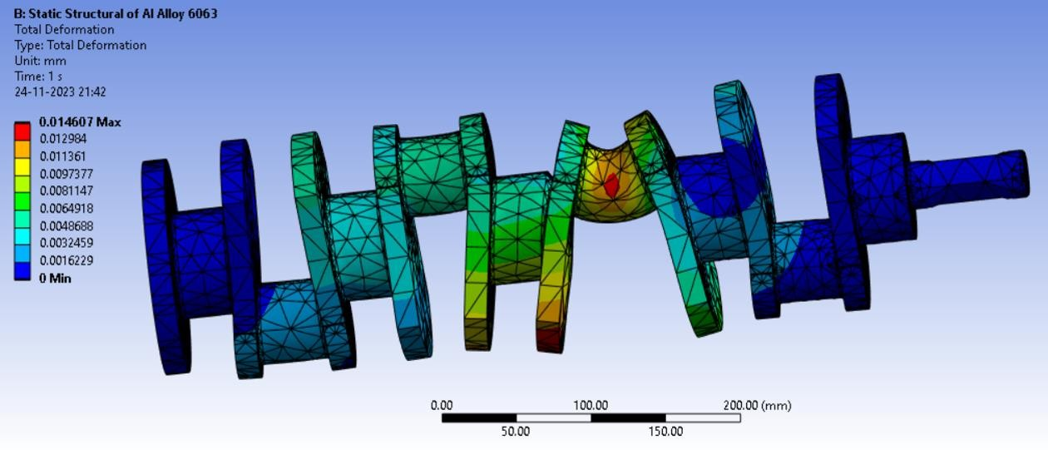Fig 18- Total Deformation of Al6063 Crankshaft

The maximum total deformation of the Aluminum Alloy 6063 crankshaft is **0.0146 mm.** The deformation is concentrated in the areas where the crankshaft bends the most, such as the crankpins and the main journals. **Equivalent stress - Aluminum Alloy 6063**

Fig 19- Equivalent Stress of Al6063 Crankshaft

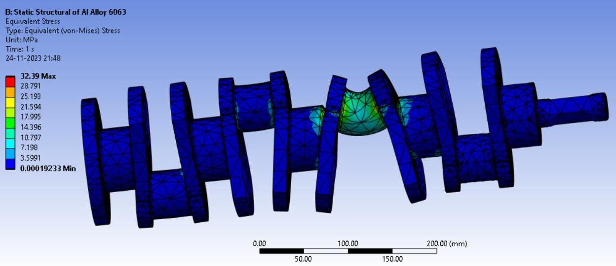

The maximum equivalent stress is **32.39 MPa,** which is located at the fillet region of the crankshaft. The equivalent stress distribution is relatively uniform over the crankshaft, with some stress concentration at the fillet regions

**Maximum Shear Stress - Aluminum Alloy 6063**

Fig 20- Maximum Shear Stress of Al6063 Crankshaft

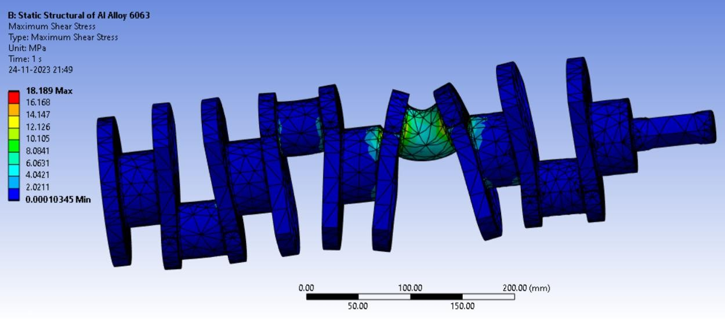

The maximum shear stress of the crankshaft is **18.189 MPa.** The shear stress is distributed evenly across the crankshaft, with the highest concentration at the center.

**Fatigue Life - Aluminum Alloy 6063**

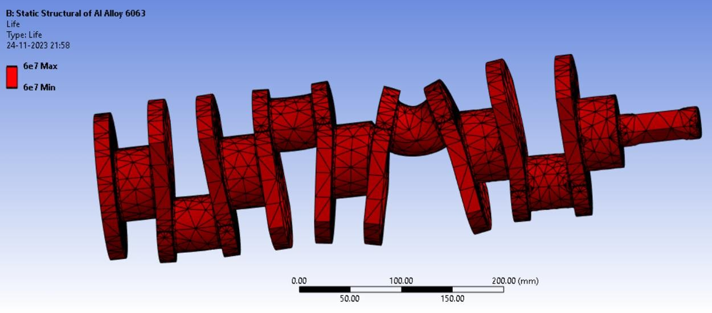Fig 21- Fatigue Life of Al6063 Crankshaft

The crankshaft has a lifespan of 6e7 Cycles, which is **approximately 11 years.**

**Weight of Aluminum Alloy 6063 (of above dimensions)**

Fig 22- Weight of Al6063 Crankshaft

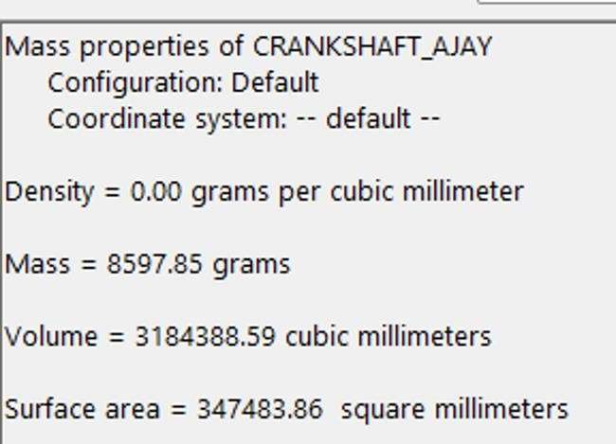

**Chapter 9**

**CONCLUSION**

We successfully achieved a substantial reduction in the weight of the crankshaft, traditionally composed of structural steel. This optimization involved transitioning to AlSiC composite and later Aluminum 6063. Addressing the challenge of cost reduction proved to be an intricate task, as finding a perfect balance between weight and cost reduction was elusive. Despite the complexity, our efforts yielded favorable results, with Aluminum Alloy 6063 emerging as a cost-effective alternative compared to steel, although it should be noted that AlSiC presented a higher cost implication. The resulting weight reduction and cost, along with other pertinent parameters, is summarized in the table below:

Table 2- Results of Analysis of Traditional Crankshaft Material (Structural Steel) vs Composite Materials (AlSiC) and Alloy (Al6063)

|  |  |  |  |  |  |  |
| --- | --- | --- | --- | --- | --- | --- |
|  | Total Deformation(mm) | Equivalent Stress(Von-Mises) | Maximum Shear Stress(MPa) | Fatigue Life(in years) | Weight(kgs) | Cost( per kg in INR) |
| Structural Steel | 0.370 | 190 | 160 | 10 | **24.8** | 60 |
| AlSiC | 0.0095748 | 32.084 | 18 | 4-5 | **9.4** | 250 |
| Aluminium Alloy 6063 | 0.0146 | 32.39 | 18.189 | 11 | **8.59** | 180 |

As evident from the table, a notable reduction in weight has been achieved while preserving structural integrity. However, it's noteworthy that the cost has increased substantially, reaching Rs.250 for AlSiC and Rs.180 for Aluminium Alloy 6063 compared to the initial Rs.50 for structural steel. Despite this cost implication, it's essential to recognize the evolving landscape of material science. The current higher cost may pave the way for future advancements and the discovery of new materials capable of simultaneously reducing both cost and weight. As material science continues to progress, there is a promising possibility of finding innovative solutions that strike an optimal balance between affordability and enhanced performance in the future

### References

### Smith, B. Johnson, C. William. "Carbon Fiber Reinforced Polymer (CFRP) Crankshafts for Automotive Applications" in Journal of Composite Materials, 2018.

### X. Chen, Y. Wang, Z. Li. "Weight Optimization of Crankshafts Using Glass Fiber Reinforced Polymers (GFRP)" in International Journal of Lightweight Materials, 2020.

### M. Patel, N. Gupta, S. Kumar. "Hybrid Composite Materials for Automotive Crankshafts: A Review" in Composite Structures, 2021.

### R. Sharma, S. Singh, P. Gupta. "Advancements in Manufacturing Processes for Composite Crankshafts" in Journal of Manufacturing Science and Engineering, 2020.

### S. K. Behera, M. K. Mishra, and S. K. Panda. "Development of a Lightweight Hybrid Composite Crankshaft for Automotive Applications" in Journal of Materials Science & Engineering A.

### J. Wang, H. Zhang, L. Chen. "Optimization of Fiber Reinforced Polymer Composite Crankshaft for Weight Reduction" in Materials & Design, 2019.

### Q. Liu, W. Li, X. Wu. "Dynamic Analysis of Composite Crankshaft in Automotive Engines" in Journal of Vibration and Control, 2017.

### G. Rodriguez, M. Garcia, E. Martinez. "Thermo-Mechanical Analysis of Hybrid Composite Crankshaft for High-Performance Applications" in Composite Part B: Engineering, 2022.

### S. Kim, Y. Lee, H. Park. "Failure Analysis and Reliability of Carbon Nanotube Reinforced Composite Crankshafts" in Engineering Failure Analysis, 2018.

### Z. Zhang, Q. Xu, Y. Wang. "Experimental Investigation of Fatigue Behavior in Glass Fiber Reinforced Polymer Composite Crankshafts" in International Journal of Fatigue, 2016.

### L. Zhao, C. Wang, Y. Liu. "Composite Materials in Automotive Engine Components: A Comprehensive Review" in Composites Part C: Open Access, 2023.

### H. Li, J. Wu, M. Xu. "Analysis of Vibration Characteristics in Hybrid Composite Crankshafts under Different Loading Conditions" in Journal of Composite Structures, 2019.